Predictions of Critical Thermal Maxima for Salmonids of Increasing Size
Introduction:
Climate change is predicted to have disproportionate impacts on coldwater fish species as they are both more sensitive to warming (Wenger et. al. 2011) and have experienced greater losses in thermal habitat (Pletterbauer et. al. 2015; Xu et al. 2024). The family Salmonidae contains many cold and cool-water species that are likely among the most sensitive freshwater species to climate warming (Parmesan 2006; Jeffrey et al. 2017). Salmonids are some of the most well-studied cold freshwater fish (Meisner 1990), and are often researched to study effects of climate change (Keleher & Rahel 1996) or changes in fish assemblages (Pletterbauer et al. 2015), but most of this research is centered in North America or Europe. Asian salmonids are less researched, and much of the knowledge used to predict climate change effects in western salmonids remains unknown in Asian species (Morita et. al. 2004).
Many inland fish populations impacted by climate change are also threatened by other anthropogenic impacts including habitat loss and degradation (Wilcove et. al. 1998; Kerr & Deguise 2004; Morita et. al. 2009; Chen et. al. 2014 ), overfishing (Post et. al. 2002; Burgess et. al. 2013; Embke et. al. 2019), and competition from introduced and invasive species (Kitchell et. al. 1997; Wilcove et. al. 1998; Morita et. al. 2004; Fausch 2007). This last threat has increased greatly over recent decades as Aquatic Invasive Species (AIS) have spread rapidly across the world (Simberloff 2000; Jang et. al. 2006; Trumpickas et. al. 2011). Introduced species tend to have strong competitive advantages over related species in similar niches (Trumpickas et. al. 2011). For example, introduced lake trout have had a large influence on the population of native cutthroat trout in Yellowstone Lake (Ruzycki et. al. 2003). In Japan, introduced centrarchids prey on native species, as well as exert trophic shifts in their introduced ecosystems (Hossain et. al. 2013).
Effects of heat waves on fish are often measured in proxy metrics like the critical thermal maximum (Baroudy & Elliott 1994; Deforges et. al. 2023), which is used to represent the upper temperature tolerance threshold. The physiological response of fish to acute and chronic heat stress greatly differs (Kilgour et. al. 1985; Ørsted et. al. 2022; González-Ferreras et. al. 2023), necessitating the measurement of critical thermal maximum to form a larger understanding of thermal ecology of a species (Galbreath et. al. 2004; Enders & Durhack 2022).
We calculated critical thermal maximum for two salmonid fishes of Hokkaido, ito and masu, in order to predict the potential outcomes of competition among these species in a warming climate. Our objectives for this study are to compare the critical thermal maximum between the two species. We hope to provide insight into the thermal ecology of native salmonids in Hokkaido to inform conservation and management decisions protecting native fishes from climate change and other threats.

Methods:
Critical thermal maximum was measured by submerging fish in an aquarium and raising the temperature at a constant rate until the loss of equilibrium (Baroudy and Elliott 1994; Hutchings et. al. 2025). We used a 1000w submersible heater placed into 9 gallons of water in a bath to maintain a heating rate of 0.3°C/min. This heating rate was chosen due to the availability of comparable studies, as variation among heating rates can lead to different resulting estimates of critical thermal maximum (Deforges et. al. 2023). The bath also contained two circulation pumps placed in opposite corners to ensure even mixing and heating. The water temperature in the bath matched the river temperatures that the fish were taken from, to help minimize incalculable heat stress.
We tested 46 masu and 22 ito for Critical Thermal Maximum (CTM). We also tested 2 white-spotted char, but did not collect enough data to make relevant conclusions. Individuals varied in fork length from 54mm to 163mm, and mass from 1.2g to 54.7g. A maximum of 8 fish were placed into the bath at a time. Only after placing the fish into the bath did we turn the heater on. Temperatures were recorded every minute of the heating in order to determine the heating rate. Recovery baths with water at stream temperatures were located near the bath to place the fish into after Loss of Equilibrium (LOE). Fish were constantly monitored during the heating in order to ensure exact LOE and temperatures were recorded. At LOE, fish were immediately removed and placed into individual recovery baths. These fish were allowed to recover in individual baths until actively swimming, before weighing and measuring. After this, fish were then placed into a large fish keeper until possible to return to native stream.
From this data, a Welch's t-test was done to determine significance between the two species. The data was plotted, and residuals were checked in order to ascertain that the differences in the data were normally distributed and independent. Multiple linear models were created in order to determine which parameters significantly contribute to our models, and were compared using Aikake’s Information Criteria (AIC). The model with the lowest AIC value is considered the most suitable model. We then paired this model with our observed data in order to visually inspect model fit. All statistics and modelling was done in R (R Core Team 2025), following methods published by Essington et. al. 2021.

Results:
Our t test yielded a p-value of < 0.001, indicating a significant difference in the LOE between ito and masu. Ito were found to have a higher LOE compared to masu (Figure 1). Average LOE temp for ito was 29.48±0.34°C. Average LOE temperature for masu was 29.02±0.47°C. We also found a much tighter spread of data points in ito compared to masu, although outliers of ito were found within the range of masu values. 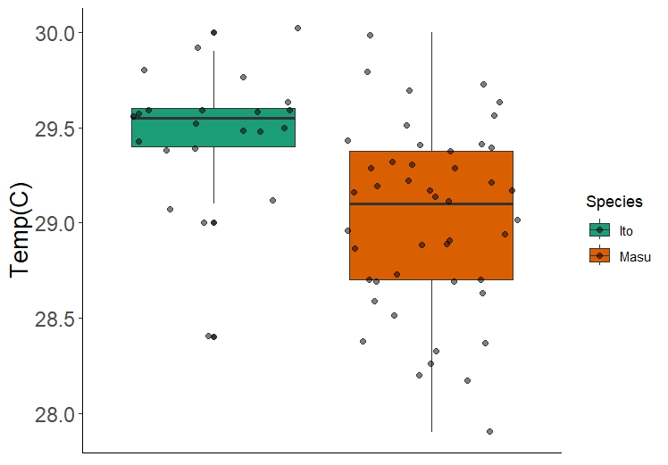Figure 1: boxplot representing the spread of values from the two species tested. Points overlaid show the true value of Temperature of LOE for individual fish. The temperature of LOE for ito was 29.48±0.34°C (green). Masu LOE was 29.02±0.47°C. A Welch`s t-test found the difference in LOE between the two species to be significant.

Assumption Checks:
The autoplot function from the ggplot2 package was used in order to test the models for our assumptions that the data collected was normally distributed. Autoplot creates a 4-paned graphic that shows 1) the Residuals vs. the Fitted model, 2) a Quantile - Quantile (QQ) plot, 3) A Scale - Location plot, and 4) Our Residuals vs. the Leverage each holds. Visual inspection confirms that the modelled data is normally distributed and is homoscedastic (Appendix A).

Model Selection:
Individual variation in body size (fork length & weight) were found to not be significant parameters in our model. Species was the only significant parameter in our models. Our model including weight and length was the lowest AIC, but the model slopes did not vary by species (Figure 2). Because of this, we believe that model 2, which allows for a slope to vary by the species, is a better fit for the data, since its AIC value has a negligible difference from our base model (Figure 3).

Table 1: An AIC table comparing the Negative Log Likelihood (NLL), AIC, and difference in AIC values from our lowest rated model (Delta).
Model | NLL | AIC | Delta
1 | -37.9664 | 65.93283 | 0
2 | -37.4844 | 67.96147 | 2.028634
3 | -37.9807 | 67.96147 | 2.028634
4 | -39.4685 | 72.93707 | 7.004239
5 | -37.5 | 70.93707 | 5.004239

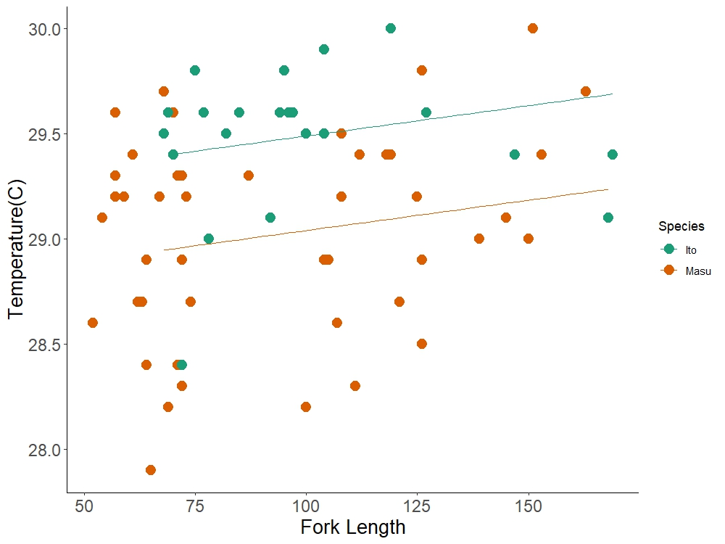
Figure 2: Scatterplot depicting LOE temperature as it varies by Fork Length. Linear models are fit using our model 1, which takes the form (Temp LOE ~ Species + Fork Length + Weight). This is our best fitting model according to AIC.
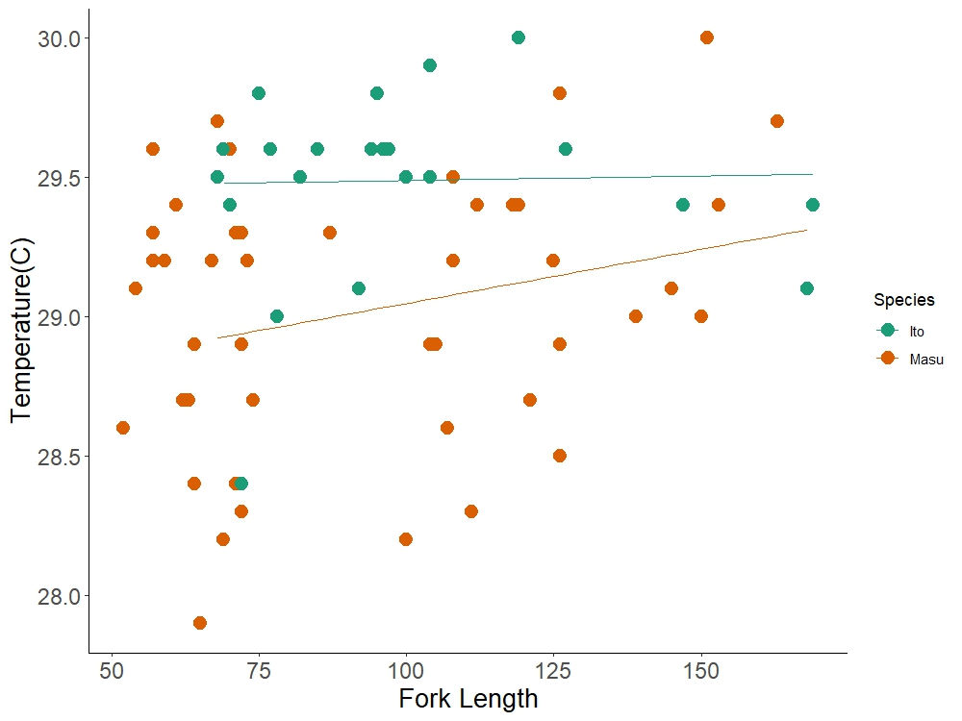Figure 2: Scatterplot depicting LOE temperature as it varies by Fork Length. Linear models are fit using our model , which takes the form (Temp LOE ~ Species * Fork Length + Weight). While this model is not the most well fitting to our data, we believe this is a better fit based on the distribution of values of our observed data.

From our selected model, we would expect masu to eventually overtake ito in terms of CTM once a certain length threshold is reached. However, in juvenile fish, it seems as though ito maintain a competitive advantage over masu.

Discussion:
Our results indicate that ito are able to withstand acute heating events better compared to masu. Even though the differences between the two species are divided by 0.5°C, this was enough to yield significant results. This result is contrary to our expectations that ito are more sensitive to extreme warming temperatures. Populations of ito have been shrinking for decades, and based on our results, this does not seem to be caused by warming temperatures in their population range, since we would expect to see a population decline in masu before ito, or paired with them if the water temperature increases enough. However, the predictive model for the ito indicates that as ito grow larger, they may become more susceptible to heating events, moreso than masu. This has been shown to be the case, in a study completed analysing mortality among adult ito in northern Hokkaido during an extreme heat wave event in 2021 (Kuroda et. al. 2025).
However, our results provide a narrow baseline that needs to be improved upon. Our sample size was limited, as our time available for this experiment was restricted, followed by additional equipment failure that prevented additional individuals from being collected for testing. Additionally, we only tested linear models, which fit our data well, but may not be the most suitable for predicting CTM as fish grow and mature in length.
While historical information indicates ito had a larger population range before industrialization, their current range has shrunk northwards more than any other direction. It is thought that the main cause for this is human development, as the current population range in Japan is strongly correlated to areas where large-scale farming has not been developed (Fukushima et. al. 2011). This roughly translates to areas where the annual average air temperature stays below 5.2°C. Ito have a range that is more restricted compared to masu, and are found wholly within the range of latitudes that masu are found in (Augerot & Foley 2005; Fukushima et. al. 2011), yet the declines in ito populations are not as apparent in masu in the same range.

References:
Achim Zeileis, Torsten Hothorn (2002). Diagnostic Checking in Regression Relationships. R
News 2(3), 7-10. URL https://CRAN.R-project.org/doc/Rnews/
Augerot, X., & Foley, D. N. (2005). Atlas of pacific salmon: The first map-based status assessment of salmon in the North Pacific. California University Press.
Baroudy, E., & Elliott, J. M. (1994). The critical thermal limits for juvenile Arctic charr Salvelinus alpinus. Journal of Fish Biology, 45(6), 1041–1053. https://doi.org/10.1111/j.1095-8649.1994.tb01071.x
Burgess, M. G., Polasky, S., & Tilman, D. (2013). Predicting overfishing and extinction threats in multispecies fisheries. Proceedings of the National Academy of Sciences, 110(40), 15943–15948. https://doi.org/10.1073/pnas.1314472110
Chen, J.-Z., Huang, S.-L., & Han, Y.-S. (2014). Impact of long-term habitat loss on the Japanese eel Anguilla japonica. Estuarine, Coastal and Shelf Science, 151, 361–369. https://doi.org/10.1016/j.ecss.2014.06.004
Desforges, J. E., Birnie‐Gauvin, K., Jutfelt, F., Gilmour, K. M., Eliason, E. J., Dressler, T. L., McKenzie, D. J., Bates, A. E., Lawrence, M. J., Fangue, N., & Cooke, S. J. (2023). The ecological relevance of critical thermal maxima methodology for fishes. Journal of Fish Biology, 102(5), 1000–1016. https://doi.org/10.1111/jfb.15368
Embke, H. S., Rypel, A. L., Carpenter, S. R., Sass, G. G., Ogle, D., Cichosz, T., Hennessy, J., Essington, T. E., & Vander Zanden, M. J. (2019). Production dynamics reveal hidden overharvest of inland recreational fisheries. Proceedings of the National Academy of Sciences, 116(49), 24676–24681. https://doi.org/10.1073/pnas.1913196116
Enders, E. C., & Durhack, T. C. (2022). Metabolic rate and critical thermal maximum CTmax estimates for westslope cutthroat trout, Oncorhynchus clarkii lewisi. Conservation Physiology, 10(1), coac071. https://doi.org/10.1093/conphys/coac071
Essington, T. E., & Essington, T. (2021). Introduction to quantitative ecology: mathematical and statistical modelling for beginners. Oxford University Press.
Fausch, K. D. (2007). Introduction, establishment and effects of non‐native salmonids: Considering the risk of rainbow trout invasion in the United Kingdom*. Journal of Fish Biology, 71(sd), 1–32. https://doi.org/10.1111/j.1095-8649.2007.01682.x
Fukushima, M., Shimazaki, H., Rand, P. S., & Kaeriyama, M. (2011). Reconstructing Sakhalin Taimen Parahucho perryi Historical Distribution and Identifying Causes for Local Extinctions. Transactions of the American Fisheries Society, 140(1), 1–13. https://doi.org/10.1080/00028487.2011.544999
Galbreath, P. F., Adams, N. D., & Martin, T. H. (2004). Influence of heating rate on measurement of time to thermal maximum in trout. Aquaculture, 241(1–4), 587–599. https://doi.org/10.1016/j.aquaculture.2004.08.004
González-Ferreras, A. M., Barquín, J., Blyth, P. S. A., Hawksley, J., Kinsella, H., Lauridsen, R., Morris, O. F., Peñas, F. J., Thomas, G. E., Woodward, G., Zhao, L., & O’Gorman, E. J. (2023). Chronic exposure to environmental temperature attenuates the thermal sensitivity of salmonids. Nature Communications, 14(1), 8309. https://doi.org/10.1038/s41467-023-43478-7
Hossain, Md. M., Perhar, G., Arhonditsis, G. B., Matsuishi, T., Goto, A., & Azuma, M. (2013). Examination of the effects of largemouth bass (Micropterus salmoides) and bluegill (Lepomis macrochirus) on the ecosystem attributes of lake Kawahara-oike, Nagasaki, Japan. Ecological Informatics, 18, 149–161. https://doi.org/10.1016/j.ecoinf.2013.07.005
Hutchings, M., Hill, J., Windle, M. J. S., & Ricciardi, A. (2025). Ecological performance of native and invasive benthic freshwater fishes under elevated temperature. Canadian Journal of Fisheries and Aquatic Sciences, cjfas-2024-0195. https://doi.org/10.1139/cjfas-2024-0195
Jang, M. ‐H., Joo, G. ‐J., & Lucas, M. C. (2006). Diet of introduced largemouth bass in Korean rivers and potential interactions with native fishes. Ecology of Freshwater Fish, 15(3), 315–320. https://doi.org/10.1111/j.1600-0633.2006.00161.x
Jeffrey, K. M., Côté, I. M., Irvine, J. R., & Reynolds, J. D. (2017). Changes in body size of Canadian Pacific salmon over six decades. Canadian Journal of Fisheries and Aquatic Sciences, 74(2), 191–201. https://doi.org/10.1139/cjfas-2015-0600
Keleher, C. J., & Rahel, F. J. (1996). Thermal Limits to Salmonid Distributions in the Rocky Mountain Region and Potential Habitat Loss Due to Global Warming: A Geographic Information System (GIS) Approach. Transactions of the American Fisheries Society, 125(1), 1–13. https://doi.org/10.1577/1548-8659(1996)125%253C0001:TLTSDI%253E2.3.CO;2
Kerr, J. T., & Deguise, I. (2004). Habitat loss and the limits to endangered species recovery. Ecology Letters, 7(12), 1163–1169. https://doi.org/10.1111/j.1461-0248.2004.00676.x
Kilgour, D. M., McCauley, R. W., & Kwain, W. (1985). Modeling the Lethal Effects of High Temperature on Fish. Canadian Journal of Fisheries and Aquatic Sciences, 42(5), 947–951. https://doi.org/10.1139/f85-119
Kitchell, J. F., Schindler, D. E., Ogutu-Ohwayo, R., & Reinthal, P. N. (1997). THE NILE PERCH IN LAKE VICTORIA: INTERACTIONS BETWEEN PREDATION AND FISHERIES. Ecological Applications, 7(2), 653–664. https://doi.org/10.1890/1051-0761(1997)007%255B0653:TNPILV%255D2.0.CO;2
Kuroda, M., Kuroki, M., Kurokawa, D., Takeda, K., & Morita, K. (2025). A heatwave-related mortality event of endangered Sakhalin taimen Parahucho perryi in northern Hokkaido, Japan. Ichthyological Research. https://doi.org/10.1007/s10228-025-01026-x
Meisner, J. D. (1990). Potential Loss of Thermal Habitat for Brook Trout, Due to Climatic Warming, in Two Southern Ontario Streams. Transactions of the American Fisheries Society, 119(2), 282–291. https://doi.org/10.1577/1548-8659(1990)119%253C0282:PLOTHF%253E2.3.CO;2
Morita, K., Morita, S. H., & Yamamoto, S. (2009). Effects of habitat fragmentation by damming on salmonid fishes: Lessons from white‐spotted charr in Japan. Ecological Research, 24(4), 711–722. https://doi.org/10.1007/s11284-008-0579-9
Morita, K., Tsuboi, J., & Matsuda, H. (2004). The impact of exotic trout on native charr in a Japanese stream. Journal of Applied Ecology, 41(5), 962–972. https://doi.org/10.1111/j.0021-8901.2004.00927.x
Ørsted, M., Jørgensen, L. B., & Overgaard, J. (2022). Finding the right thermal limit: A framework to reconcile ecological, physiological and methodological aspects of CTmax in ectotherms. Journal of Experimental Biology, 225(19), jeb244514. https://doi.org/10.1242/jeb.244514
Parmesan, C. (2006). Ecological and Evolutionary Responses to Recent Climate Change. Annual Review of Ecology, Evolution, and Systematics, 37(1), 637–669. https://doi.org/10.1146/annurev.ecolsys.37.091305.110100
Pletterbauer, F., Melcher, A. H., Ferreira, T., & Schmutz, S. (2015). Impact of climate change on the structure of fish assemblages in European rivers. Hydrobiologia, 744(1), 235–254. https://doi.org/10.1007/s10750-014-2079-y
Post, J. R., Sullivan, M., Cox, S., Lester, N. P., Walters, C. J., Parkinson, E. A., Paul, A. J., Jackson, L., & Shuter, B. J. (2002). Canada’s Recreational Fisheries: The Invisible Collapse? Fisheries, 27(1), 6–17. https://doi.org/10.1577/1548-8446(2002)027%253C0006:CRF%253E2.0.CO;2
R Core Team (2025). _R: A Language and Environment for Statistical Computing_. R Foundation for Statistical Computing, Vienna, Austria. <https://www.R-project.org/>.
Ruzycki, J. R., Beauchamp, D. A., & Yule, D. L. (2003). EFFECTS OF INTRODUCED LAKE TROUT ON NATIVE CUTTHROAT TROUT IN YELLOWSTONE LAKE. Ecological Applications, 13(1), 23–37. https://doi.org/10.1890/1051-0761(2003)013%255B0023:EOILTO%255D2.0.CO;2
Simberloff, D. (2000). Global climate change and introduced species in United States forests. Science of The Total Environment, 262(3), 253–261. https://doi.org/10.1016/S0048-9697(00)00527-1
Trumpickas, J., Mandrak, N. E., & Ricciardi, A. (2011). Nearshore fish assemblages associated with introduced predatory fishes in lakes: INTRODUCED PREDATORS STRUCTURE LITTORAL FISH ASSEMBLAGES. Aquatic Conservation: Marine and Freshwater Ecosystems, 21(4), 338–347. https://doi.org/10.1002/aqc.1192
Wenger, S. J., Isaak, D. J., Luce, C. H., Neville, H. M., Fausch, K. D., Dunham, J. B., Dauwalter, D. C., Young, M. K., Elsner, M. M., Rieman, B. E., Hamlet, A. F., & Williams, J. E. (2011). Flow regime, temperature, and biotic interactions drive differential declines of trout species under climate change. Proceedings of the National Academy of Sciences, 108(34), 14175–14180. https://doi.org/10.1073/pnas.1103097108
Wilcove, D. S., Rothstein, D., Dubow, J., Phillips, A., & Losos, E. (1998). Quantifying Threats to Imperiled Species in the United States. BioScience, 48(8), 607–615. https://doi.org/10.2307/1313420
Wickham H, Averick M, Bryan J, Chang W, McGowan LD, François R, Grolemund G, Hayes A, Henry L, Hester J, Kuhn M, Pedersen TL, Miller E, Bache SM, Müller K, Ooms J, Robinson D, Seidel DP, Spinu V, Takahashi K, Vaughan D, Wilke C, Woo K, Yutani H (2019). “Welcome to the tidyverse.” _Journal of Open Source Software_, *4*(43), 1686. doi:10.21105/joss.01686 <https://doi.org/10.21105/joss.01686>.
Xu, L., Feiner, Z. S., Frater, P., Hansen, G. J. A., Ladwig, R., Paukert, C. P., Verhoeven, M., Wszola, L., & Jensen, O. P. (2024). Asymmetric impacts of climate change on thermal habitat suitability for inland lake fishes. Nature Communications, 15(1), 10273. https://doi.org/10.1038/s41467-024-54533-2
Yang, Z.-H., Fang, K.-T., & Liang, J.-J. (1996). A characterization of multivariate normal distribution and its application. Statistics & Probability Letters, 30(4), 347–352. https://doi.org/10.1016/S0167-7152(95)00238-3

Appendix:
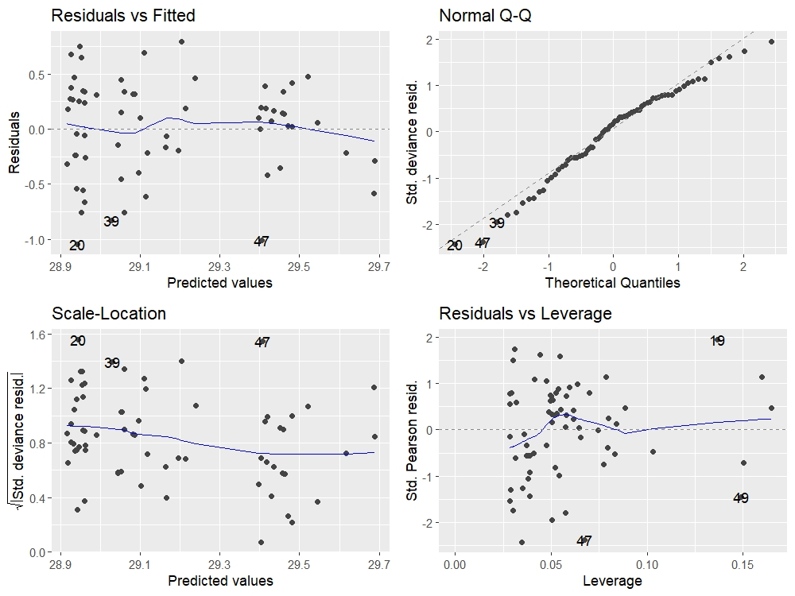Figure 2: Output of the function “Autoplot” when applied to our eventual final model. Based on the results of these plots, we can conclude that our data is linear and normally distributed, and our model well-fitting enough to proceed with modelling of the data.

